Project: Mobile-Based Attendance Management System (MBAMS)
Team: Group 12
Date: 24/05/2025
Course: CEF440 - Internet Programming and Mobile Development
Instructor: Dr. Nkemeni Valery

1. Introduction
This report documents the system architecture and deployment diagrams for the Mobile-Based Attendance Management System, which uses geofencing and facial recognition for secure attendance tracking. The backend server is implemented using Firebase for real-time data synchronization and scalability.

2. System Overview
The system consists of:
- Mobile App (Android/iOS): Built with React Native for cross-platform compatibility.
- Firebase Backend: Handles authentication, data storage, and real-time updates.
- Facial Recognition Module: On-device face verification (using face api .js).
- Geofencing Module: Validates student location via GPS.

3. Deployment Diagram

3.1 Diagram Representation
Below is the Deployment Diagram illustrating the system’s physical and software components:
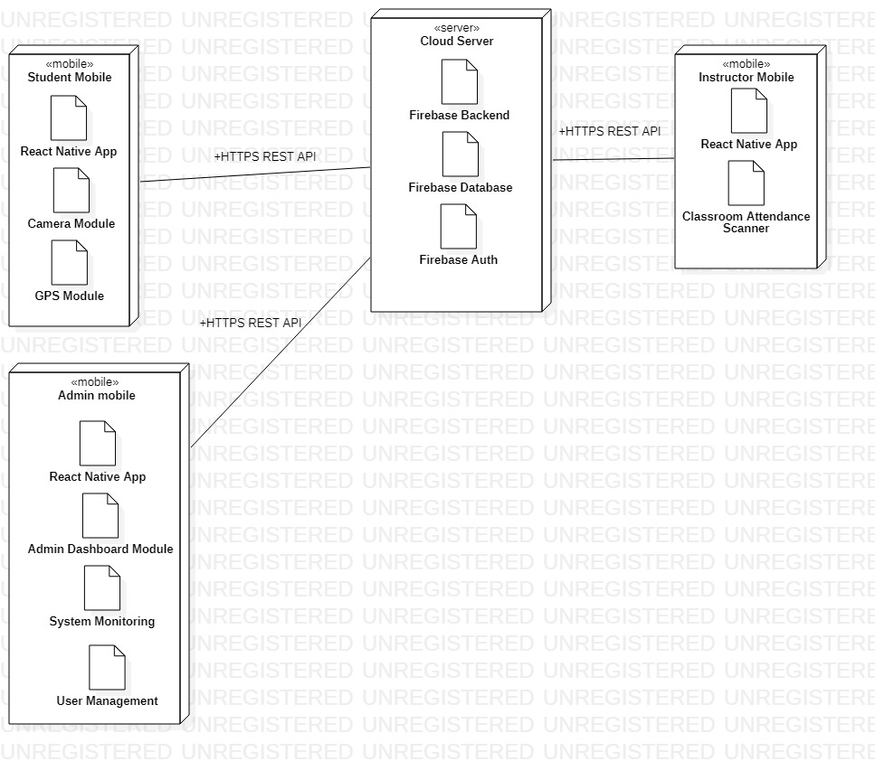

3.2 Key Components

Component | Role
Mobile Device | Hosts the app; runs facial recognition and geofencing.
Firebase Backend | Manages authentication, real-time data (Firestore), and cloud functions.
Firestore Database | Stores attendance records, user profiles, and geofence coordinates.
Firebase Authentication | Handles secure login (email/password, biometrics).
Facial Recognition | On-device AI model for identity verification.
Geofencing Module | Validates student location before marking attendance.

3.3 Communication Protocols
- HTTPS: Secure API calls between mobile app and Firebase.
- WebSockets: Real-time sync for attendance monitoring (Firestore listeners).

4. Activity Diagram: "Make a Complaint"

4.1 Diagram Flow

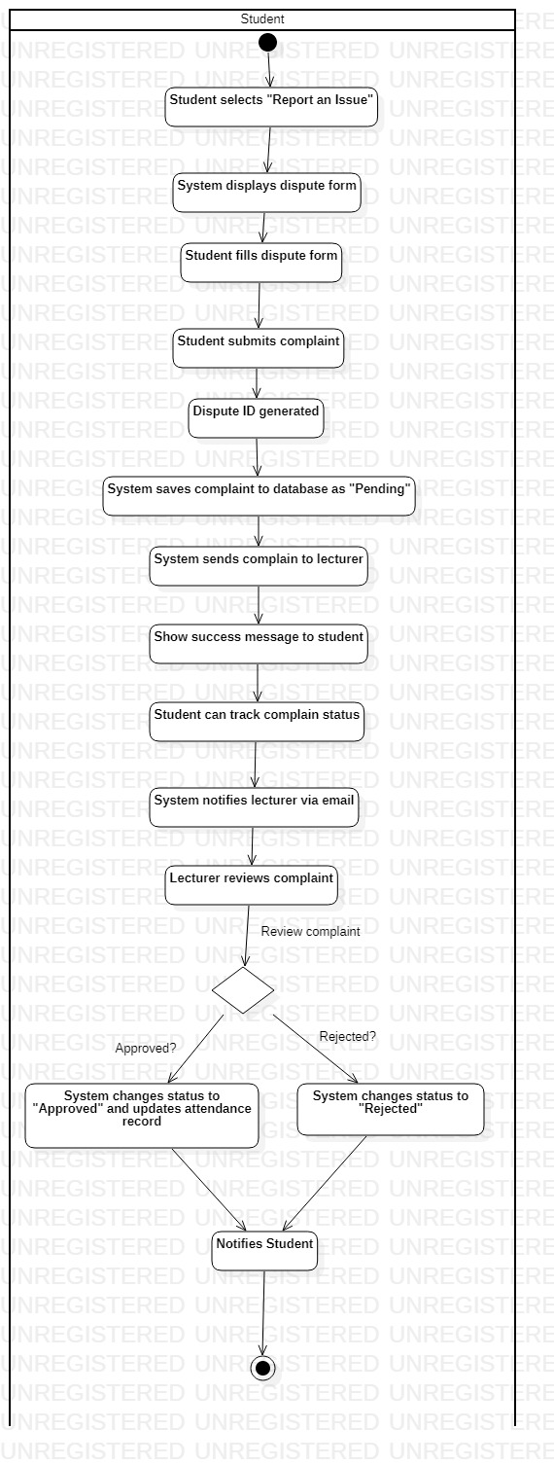

4.2 Key Steps

1. Complaint Submission: Student fills a form (stored in Firestore).
2. Real-Time Alert: Firebase triggers an email to the lecturer.
3. Resolution: Lecturer updates attendance status.
4. Notification: Student receives in-app/email confirmation.

5. Sequence Diagrams

1. "Track Attendance per Course"
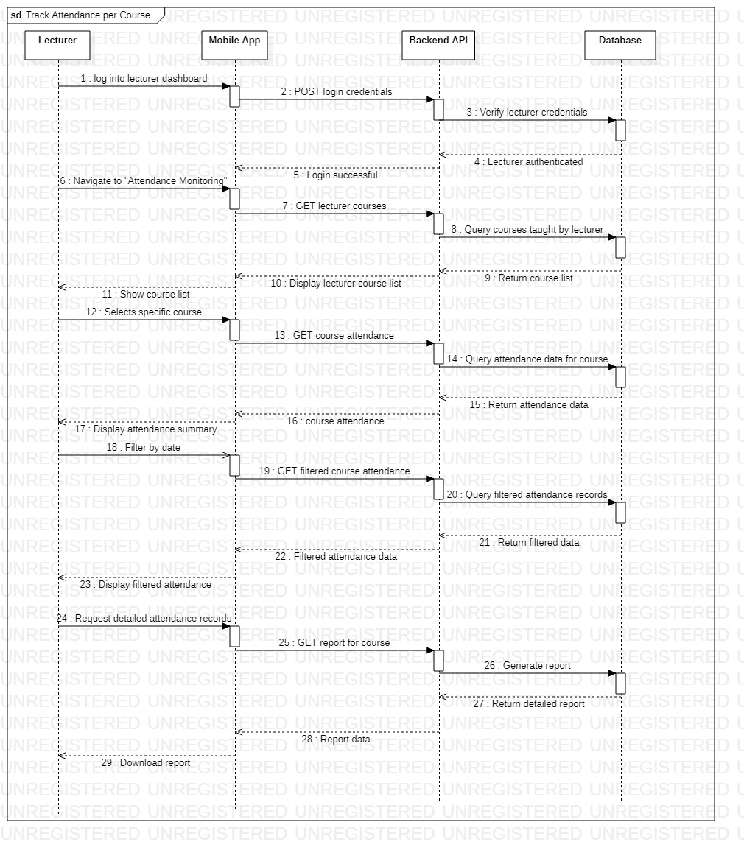

5.1 Diagram Flow

5.2 Process Explanation
1. Lecturer Request: Opens attendance dashboard.
2. Firestore Query: Mobile app fetches data from Firestore (filtered by course/date).
3. Real-Time Updates: Firebase listeners auto-refresh the UI when data changes.

2. "Make a Complaint"

5.3 Diagram Flow

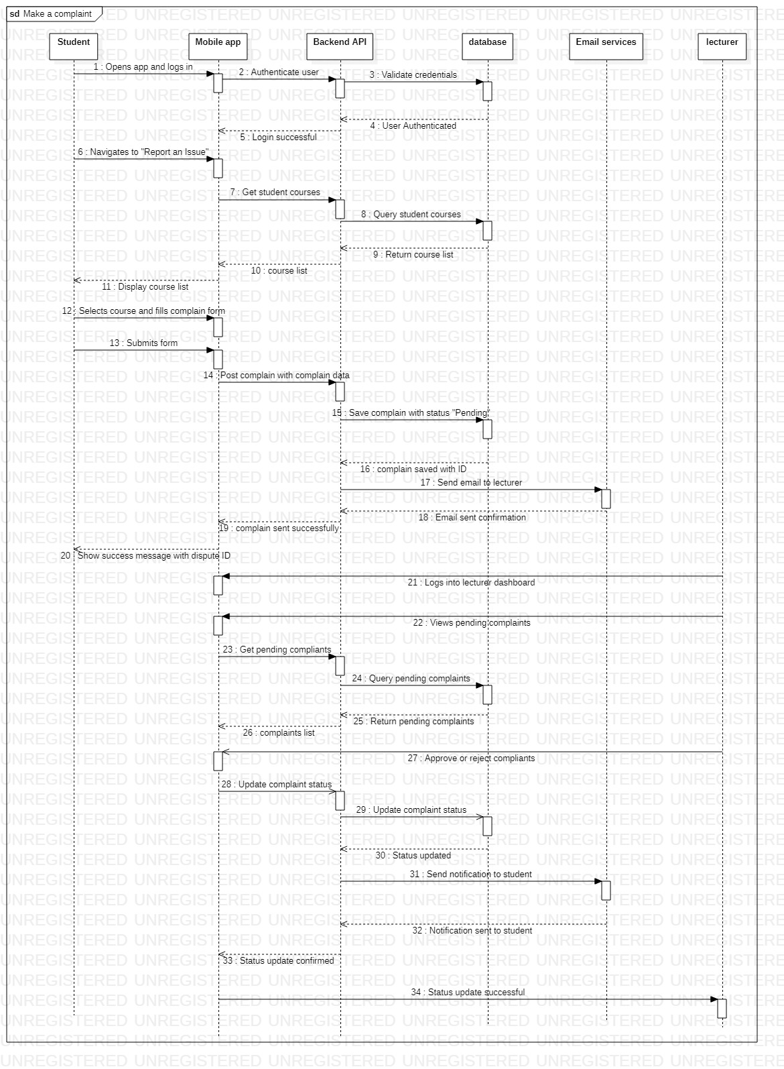

5.4 Process Explanation

- Submission
  - Student submits complaint through mobile app
  - Complaint is saved to Firebase under /complaints/[courseID]
- Notifications
  - Automatic email sent to lecturer
  - Instant push alert to admin devices
- Resolution
  - Lecturer reviews and updates status
  - Student sees real-time update (<0.5 sec delay)

7. Conclusion
The key diagrams (Deployment, Activity, Sequence) clarify system interactions, ensuring smooth development and deployment.

